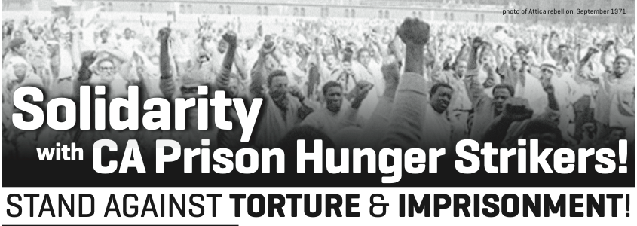
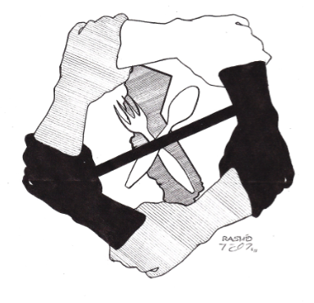
On July 1st, prisoners in the Pelican Bay SHU started an indefinite hunger strike to protest the torturous and inhumane conditions of their imprisonment. At least 6,600 prisoners across 13 prisons have joined the strike in solidarity. The courageous actions of these prisoners have gained support across the world, as people inside and outside have come together to show solidarity with the struggle at Pelican Bay.
The Demands:
1. End “Group Punishment & Administrative Abuse

2. Abolish Debriefing Policy & Modify Active/Inactive Gang Status Criteria

3. Comply with the US Commission on Safety & Abuse in America’s Prisons 2006 Recommendations regarding an End to Long-term Solitary Confinement

4. Provide Adequate & Nutritious Food

5. Expand & Provide Constructive Programming & Privileges for Indefinite SHU Status Prisoners

* The practice of “debriefing,” or offering up information about fellow prisoners particularly in regard to gang status, is often demanded in return for better food or even release from the SHU. Debriefing puts the safety of prisoners and their families at risk, because they are then viewed as “snitches.”

Despite the growing support for this historic hunger strike, the CA Department of Corrections and Rehabilitation (CDCR) has refused to negotiate with the prisoners.

Stand with the Prisoners!
Support Them in Winning Their Demands!

Call Secretary of the CDCR & your representatives and urge them to negotiate with the prisoners and honor their demands!

Matthew Cate: (916) 323-6001
Governor Jerry Brown: (916) 445-2841
CDCR Public Affairs Office: (916) 445-4950

Sample Script:
“Hi my name is ____ and I live in California. I'm calling about the statewide prisoner hunger strike that began at Pelican Bay.
I support the prisoners & their reasonable "five core demands."
I urge the CDCR to negotiate with the prisoners immediately & in good faith. Thank you."

Call your Legislators too!
For SF: Tom Ammiano: (916) 319-2013 & Mark Leno: (916) 651-4003
For Oakland: Loni Hancock: (916) 651-4009 For Berkeley: Nancy Skinner (916) 319-2014

Sample Script:
“Hi my name is _______ and live in your district. I'm calling about the statewide prisoner hunger strike that began at Pelican Bay. I support the prisoners & their reasonable "five core demands." I urge you to make sure the CDCR negotiates with the prisoners immediately & in good faith. Thank you."

